Catholic Junior College
JC2 Preliminary Examination
Higher 2



Instruction

GEOGRAPHY 9173/01
Paper 1 27 August 2026
INSERT
3 hours

READ THESE INSTRUCTIONS FIRST
This Insert contains all the resources referred to in the questions.

This document consists of 9 printed pages and 1 blank page.
Resource 1 for Question 1
Annual hydropower generation (measured in terawatt-hours, TWh) in 1999 and 2024
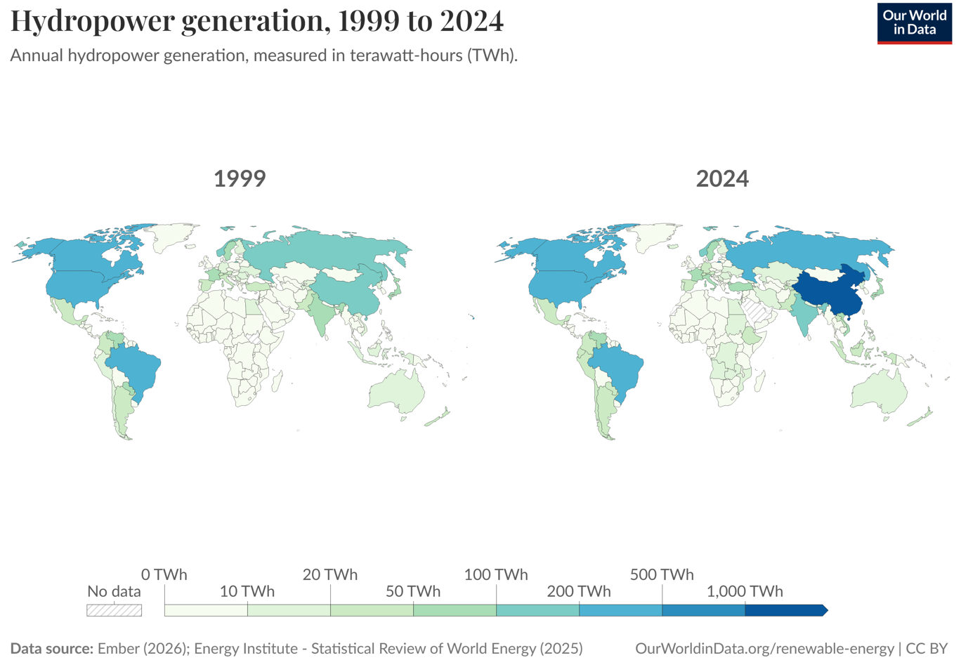
Resource 2 for Question 1
Map of dams and power plants in the Lancang‐Mekong River Basin
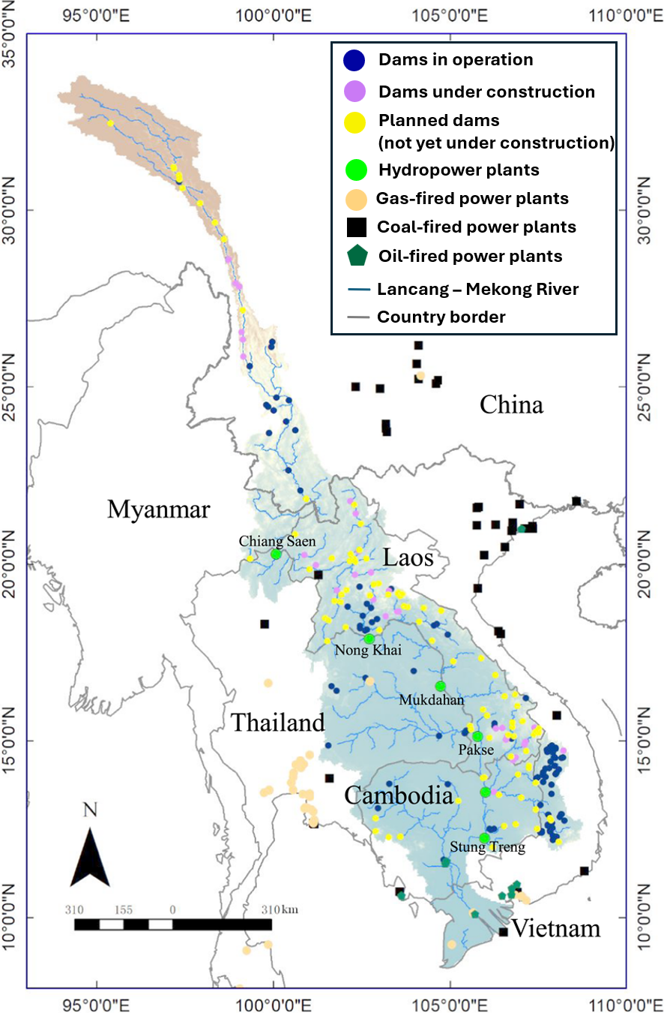
Resource 3 for Question 1

Power supply structure of countries in the Lancang-Mekong River Basin
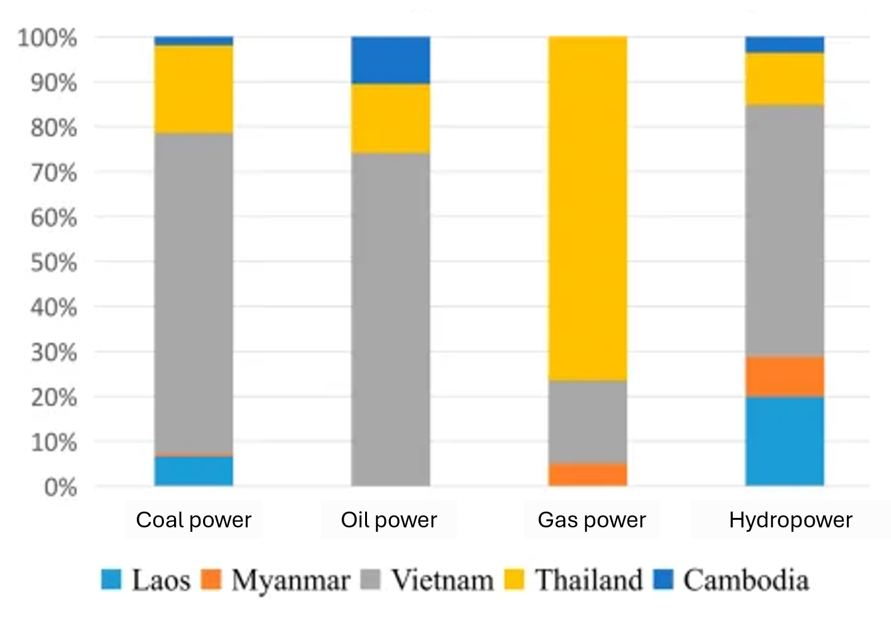
Resource 4 for Question 1
Vietnam’s exports from 2000 to 2022
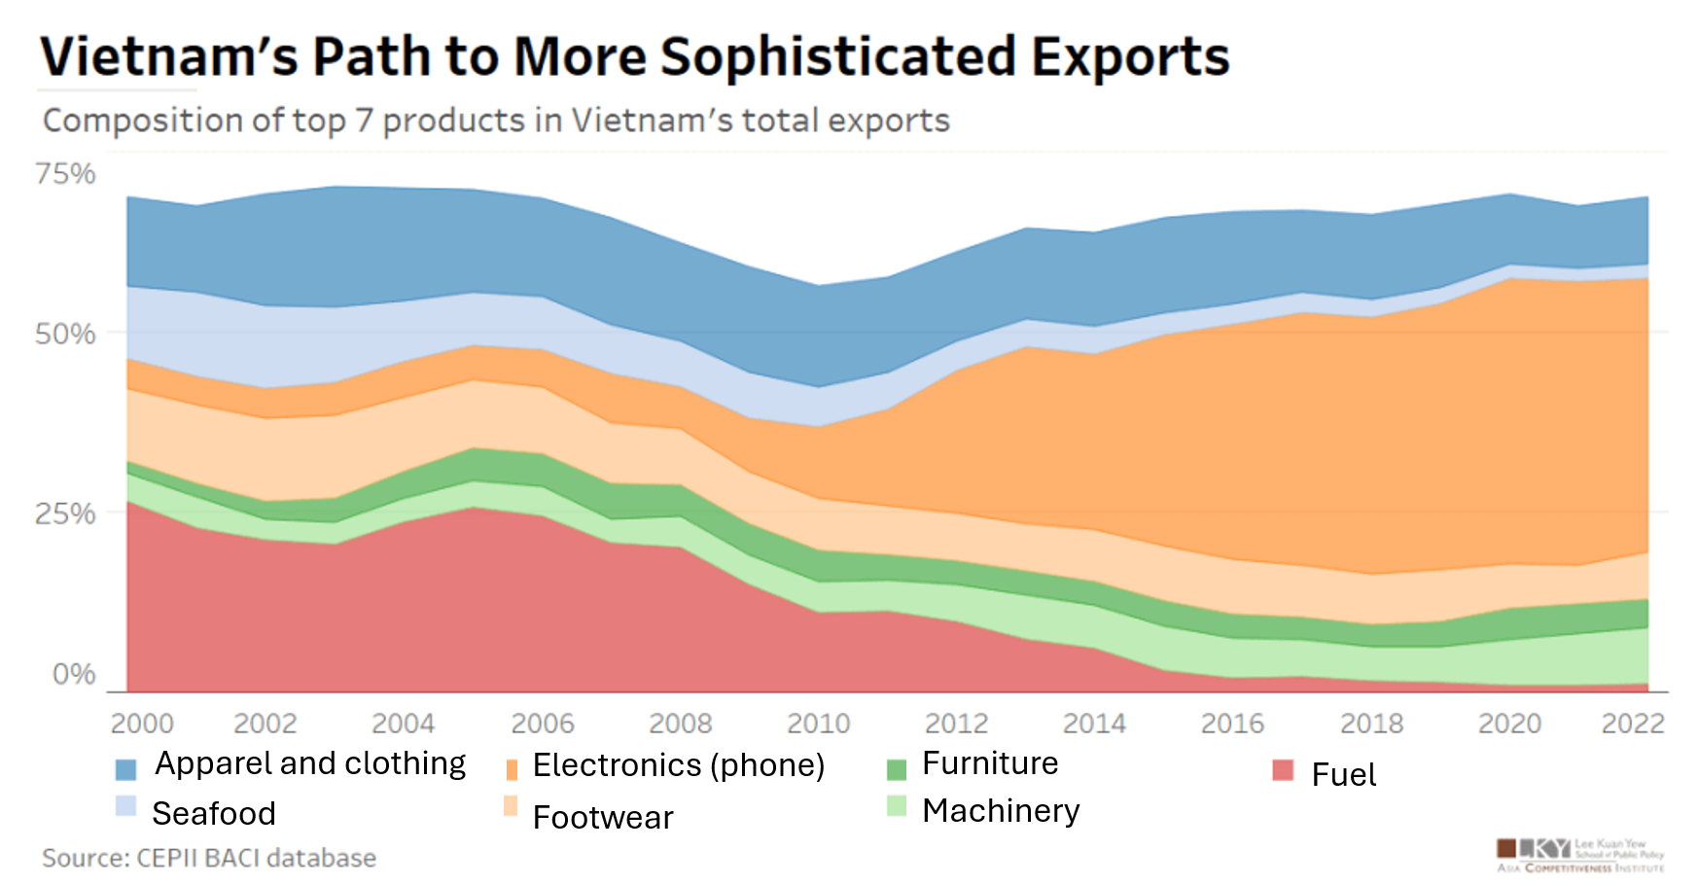
Note:
- Exports refer to the goods produced in Vietnam and sold to other countries

Resource 5 for Question 2
Development of Typhoon Odette in December 2021
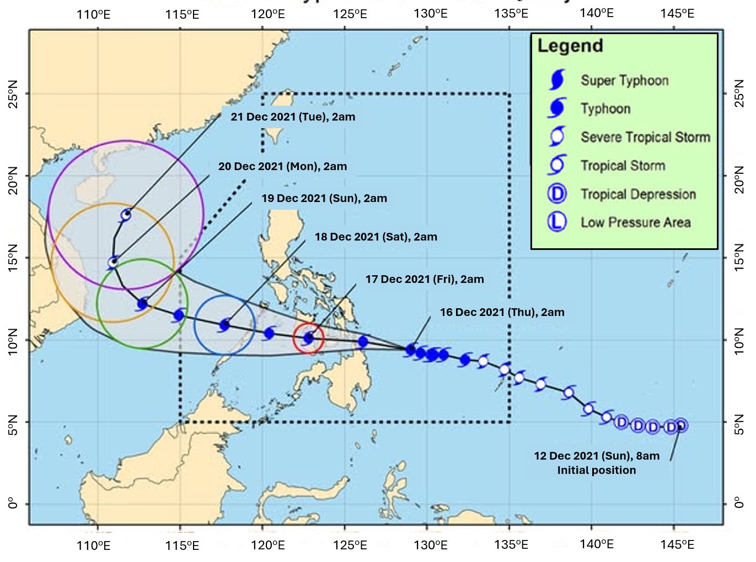
Resource 6 for Question 2

Sea surface temperatures over the Pacific Ocean between 29 November and 5 December 2021

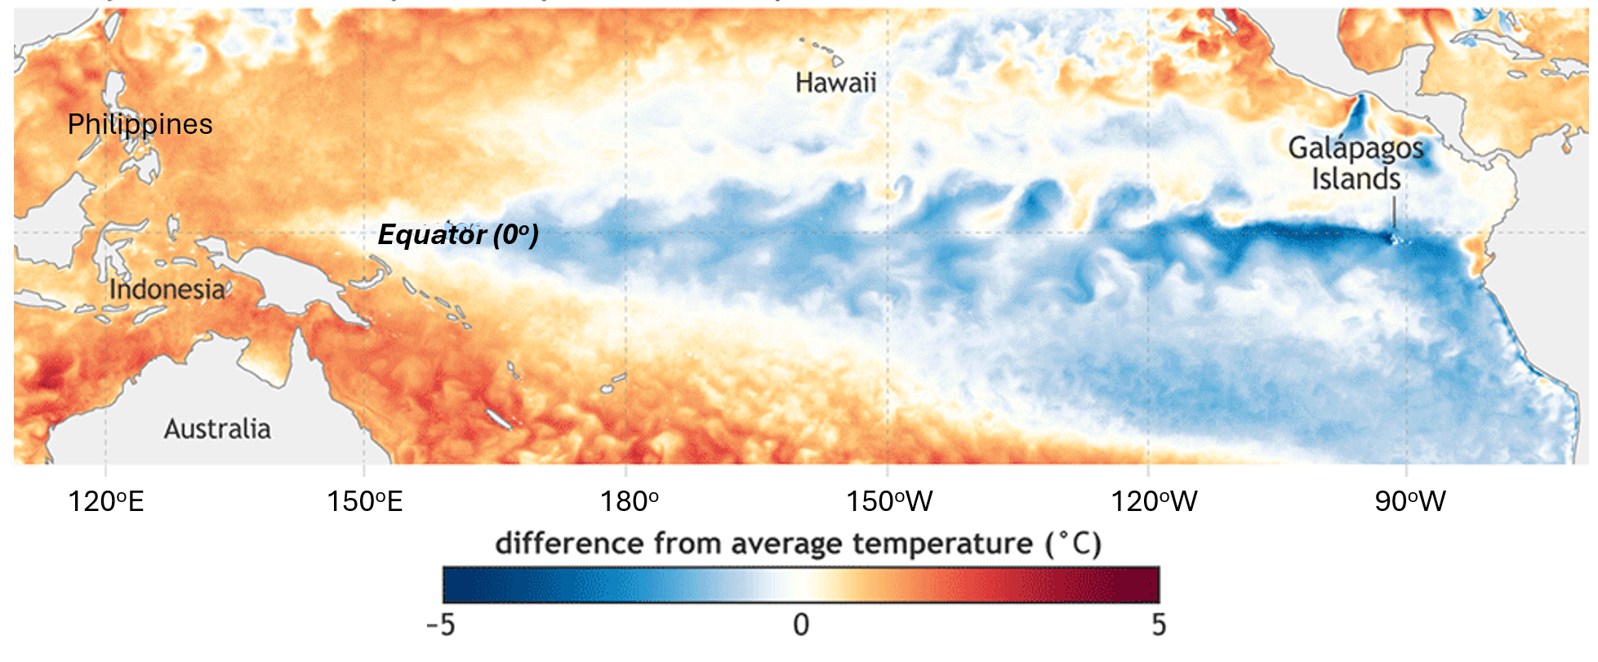

Resource 7 for Question 2
Slope failure in the Philippines in December 2021
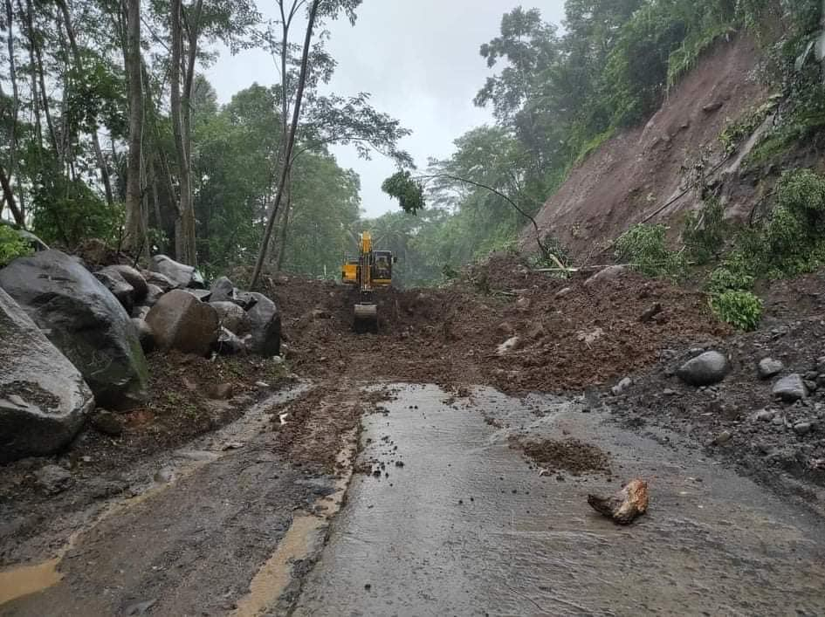

Resource 8 for Question 2

A cartoon on fluvial flood management in the Philippines

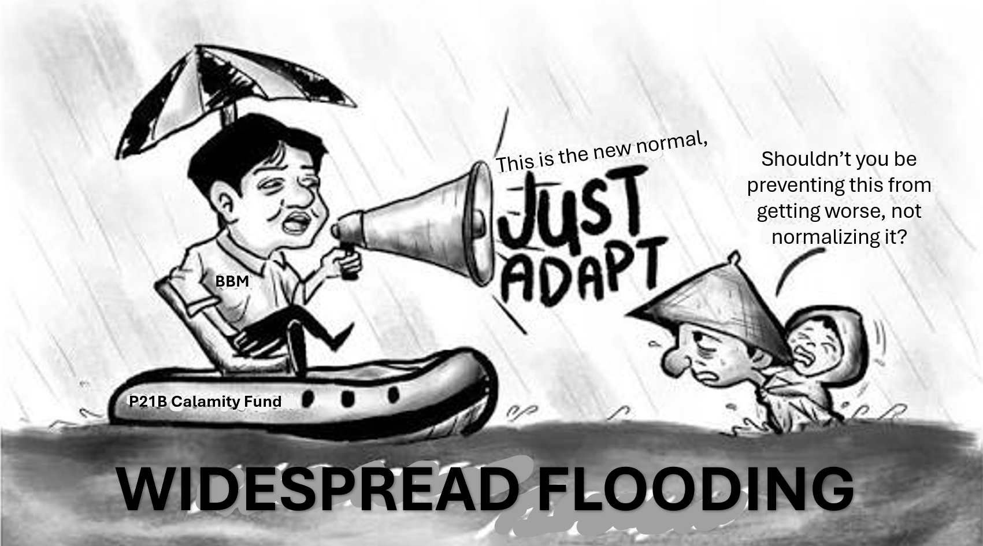
Notes:
- BBM refers to Bongbong Marcos, the President of the Philippines.
- The P21B calamity fund refers to the ₱21 billion (approximately US$344.86 million) allocated to finance disaster aid, relief operations, and rehabilitation projects.

BLANK PAGE

Resources
Question 1 Resource 1 [Source: https://ourworldindata.org/grapher/hydropower-generation]
Question 1 Resource 2 [Source: https://www.researchgate.net/figure/Overview-of-the-Lancang-Mekong-River-Basin-gauging-stations-eco-nodes-hydropower_fig1_366093838]
Question 1 Resource 3 [Adapted from: https://www.frontiersin.org/journals/energy-research/articles/10.3389/fenrg.2023.1109254/full]
Question 1 Resource 4 [Adapted from: https://aciperspectives.com/2024/04/12/chart-of-the-week-april-12-2024%E2%94%82-vietnams-path-to-more-sophisticated-exports/]
Question 2 Resource 5 [Source: https://www.facebook.com/PAGASA.DOST.GOV.PH/posts/tropical-cyclone-bulletin-no-8typhoon-odettephissued-at-500-am-16-december-2021v/4438891162887425/]
Question 2 Resource 6 [Source: https://www.climate.gov/news-features/blogs/enso/december-2021-la-ni%C3%B1a-update-visual-aids]
Question 2 Resource 7 [Source: https://www.rappler.com/philippines/department-agriculture-typhoon-odette-destroyed-farms-northern-mindanao/]
Question 2 Resource 8 [Source: https://www.facebook.com/ManilaStandardPH/posts/opinionaited-september-9-2025-flood-relief-or-flood-of-liesprompta-horizontal-ed/1227912752714332/]

